AATC_Drone_Logic

The AATC_Drone_Logic module is used to act as a drone / act as a template for the logic of a real drone. The program simulates a drone connecting to a server, obtaining flights and flying these flights. In order to do this the drone must keep track of it’s current position as well as obtain the details about the drone it is supossed to immitate. This is done by keeping a coordinate object containing the current location of the drone as well as obtaining the details of the drone from the server so that the drone simulation can immitate the drone.

The program has two main components, the logic system and the drone hardware immitation system, both in seperate threads. The logic system acts as an interface to the server, checks for flights and updates the status of the drone while the hardware system simulates movement. They are seperated as the communication between the drone and the server may be blocking , if they were not in seperate threads the drone could not react while waiting for a response from the server. The threads communicate between each other via queues, the hardware thread sending information about the status of the drone or the completion of the flight to the logic thread while the logic thread sends details about flights to the hardware thread.

The Logic thread also has control of the GPIO LEDs on a raspberry pi, providing indications about the status of the drone. This may indicate if the drone is waiting, active, flying , has a connection error or login error. The program must have access to the DroneID as well as the password for the drone in order to login.

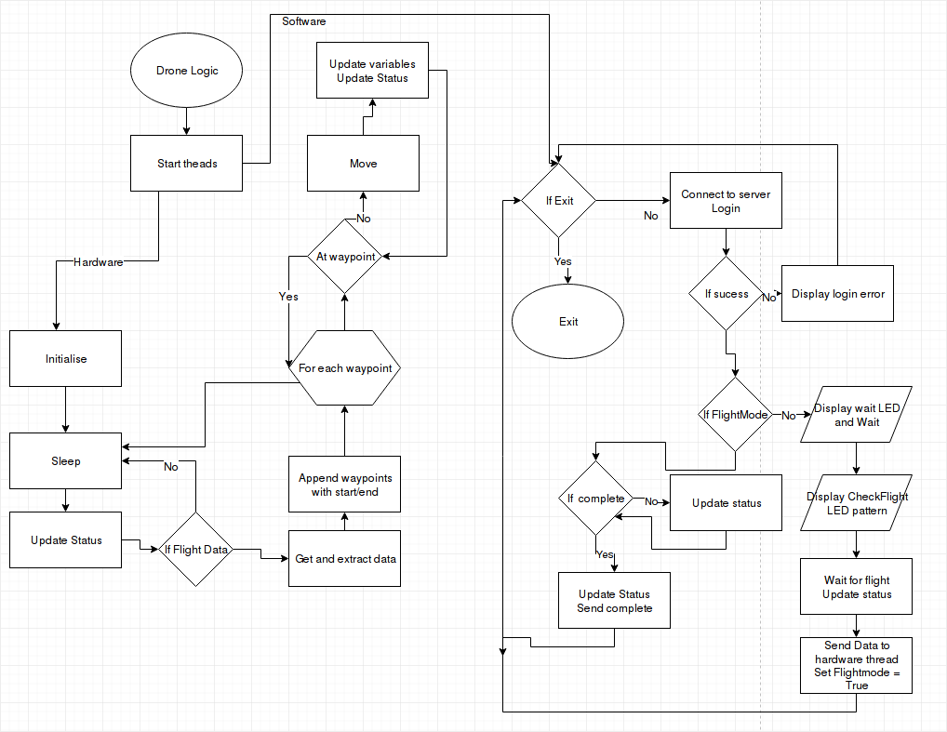

Import
The AATC_Drone modules is used to connect to the server and communicate simply via methods. The queue module is used to communicate between threads, the threading module is used for the threading of hardware and logic processes. The time module is required to allow the drone to sleep if necessary. The AATC_GPIO module is used for the Thread controller object to manage the GPIO pins in a seperate thread. The random module is used to introduce a random factor the the battery drain. The AATC_Config module is required for loading constants. The AATC_Coordinate module is required for general functions for coordinate objects as well as the coordinate objects.

DroneLogicSystem
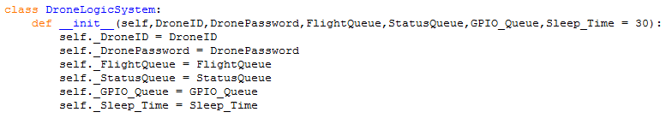
The DroneLogicSystem class is the class which runs the logic components of the drone simulation. This involves the communication between the drone and the server, converting flight data and updating the status of the drone. The object requires 5 parameters when created and has one optional parameter. The integer DroneID and string DronePassword arguments are used to sign into the server. The FlightQueue and StatusQueue arguments are queue objects used to communicate with the hardware thread. The GPIO_Queue object is required to allow the drone logic to communicate with the GPIO thread controlling the LEDs. The optional sleep time parameter is used to control the time in seconds which the server will wait on an error or between checking for flights, a value of 30+ seconds prevents the server being constantly sent messages i.e. if the logic credentials are incorrect.

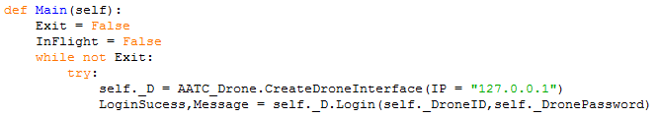
The main method runs constantly until the exit is set to True ( eg feature could be added after 10 failed login attempts to shutdown drone). The InFlight boolean variable is used to set if the drone is currently running a flight or not, which then controls which subroutine the main method should call. The contents of the loop are contained in a try/ except bracket as if there is a connection failure an exception will be raised. The loop will then attempt to reconnect to the server repeatedly. The program creates an attribute in which to store the DroneInterface object and connects to the server. The DroneInterface object is then used to log into the server using the given credentials, returning the success and message of the command.

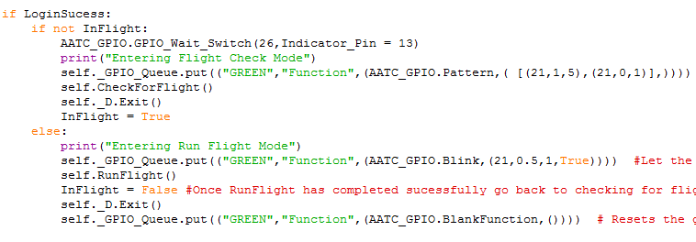
Should the login succeed then the program will continue. If the program is currently not InFlight mode then the program will switch to the check for flight section.

The check for flight section is used to obtain flights for the drone. First the program waits using the AATC_GPIO.GPIO_Wait_Switch procedure, waiting for the switch on pin 13 to allow the flight to start. This feature can be used to temporarily prevent drone from flying in case i.e. the drone needs to be checked for damage, preventing it from attempting to fly. Once this procedure is complete the program will start the green LED waiting pattern involving 5 seconds on and 1 second off repeats, signifying that the drone is searching for a flight. The CheckForFlight subroutine is then called, remaining running until a flight is found. Once a flight is found the DroneInterface is closed gracefully and the drone switches to InFlight mode.

Should the Drone be in flight mode the green LED will be flashing at 0.5Hz and the RunFlight method will be started, managing the flight until it is completed. Once the flight is completed the drone will exit the InFlight mode, exit the DroneInterface connection and disable the green LED indicator by passing in a blank function.

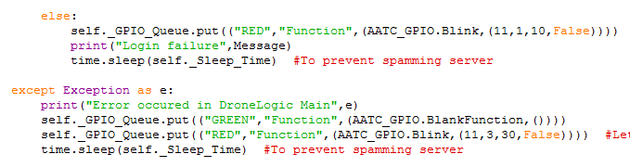
Should the LoginSuccess be False then the else statement will be executed. This will start a 1Hz blinking red light and display the returned message , then sleep for the given sleep time, preventing spamming the server with login requests.

Should an error occur in the execution of the main loop it will be caught in the except bracket. The error will be displayed, the green LED disabled , the red LED set to blink at 3Hz to indicate a large error. Finally the program will sleep for the set sleep time.

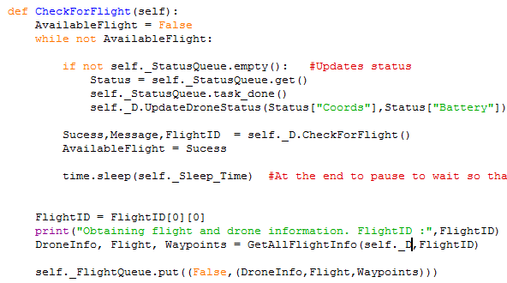
The Check for flight method is used to obtain the details for a flight if applicable. The program loops until a flight is available , updating the status of the drone on the server if the status queue is not empty. Additionally a check for a flight is run, setting the success marker to the AvailableFlight variable, exiting the loop if a flight is available. Once a flight is available the FlightID is extracted ( ((FlightID,),) format ) and used to obtain the details of the flight using the GetAllFlightInfo method ( which obtains all the details for the flight in a useful form). Finally these details are placed into the FlightQueue to be transferred to the drone hardware thread.

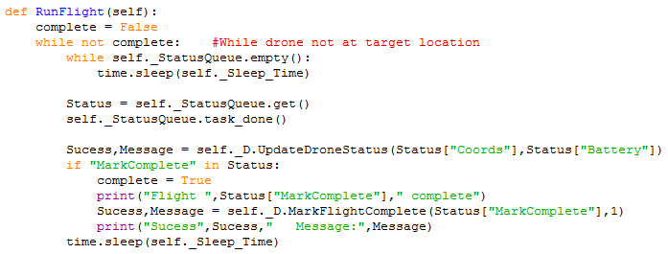
The RunFlight method is run while the Drone is in flight. The while loop continues until the flight is marked as complete by the drone. If the StatusQueue is empty the program will wait until it is filled. Then the item in the queue will be removed and the task marked as done ( not strictly needed). The drone then updates it’s status using the DroneInterface object. Should the MarkComplete key be in the dictionary sent in the queue then the program will have completed the flight. The complete variable is set to True and the flight marked as complete using the value in the key value pair for MarkComplete as the FlightID with the completion code defaulting to 1. Then the program will sleep for the required amount of time.

Misc
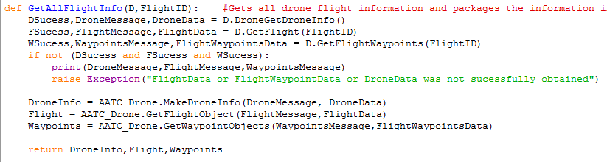
The GetAllFlightInfo function is used to obtain all the flight and drone data using a single function. This data is required to perform the flight simulation. The function takes the DroneInterface object D and the integer FlightID. The data is obtained for the drone, flight and flight waypoints, should any of these requests fail then an exception is raised. The data for each component is the converted into a python object which is simpler to work with. These objects are then returned.

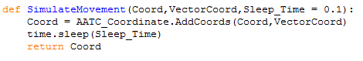
The SimulateMovement method is used to simulate the movement of the drone. The method takes the Coordinate objects Coord, VectorCoord and optionally the integer sleep time. The coordinate is incremented using the AddCoords method by the VectorCoord. The program then sleeps for the Sleep_Time value, this value controls how quickly the simulation will run, 1 second being real time, 0.1 seconds being 10x faster than expected ( to ensure flights do not take multiple hours).

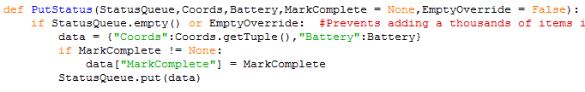
The PutStatus procedure is used to update the status queue with a new value. The method takes the StatusQueue, current coords coordinate object , the integer battery value, optionally the MarkComplete value as well as the EmptyOverride value. Should the StatusQueue have an item in the queue i.e. the previous status message has not yet been processed then the procedure will not continue as otherwise there is the issue of the queue filling up, adding greater latency to the status update procedure. For example if the drone fails to connect to the server the program will not fill the queue will unprocessed status messages, instead waiting for the previous message to be processed. This prevents the status on the server being delayed further and further as the queue grows. The EmptyOverride method is used to force the item to be added to the queue, i.e. if the flight has been completed the MarkComplete message must be sent.
Should this check pass the data is created as a dictionary with the Coordinate in tuple form as well as the battery. Should MarkComplete be not None then it also is added to the dictionary. Finally this data is placed in the status queue.

The DecrementBattery function is used to decrement the battery based off the distance travelled in the last step. This requires the DroneInfo object, the two pairs of coordinates and the current battery level. The distance is calculated in meters between the two coordinates using the AATC_Coordinate.DeltaCoordToMetres function, which is then used to calculate the amount the battery should be decremented by. This is calculated by finding the proportion of the range the distance covers, scaling this to a 100% scale, multiplying by a random function from 0.9-1.1 and the AATC_Config.DRONE_BATTERY_DRAIN_MULT constant. The battery is then decremented by this value and returned.

DroneHardware
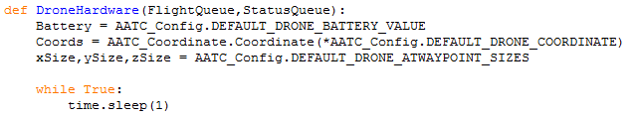
The DroneHardware procedure is used to imitate the movement of the drone in the simulation. As this is a simulation and the program does not have access to hardware sensors to obtain the current coordinates and battery level or the physical speed limitations of the drone. Therefore the simulation must keep track of these variables or obtain them from the server. In order to simulate movement the drone must keep track of it’s current coordinates and use the target coordinates and speed to calculate movement vectors to simulate movement in 1 second.

First the program loads the relevant default values for certain attributes of the simulated drone such as Battery level, current coordinates and the acceptable distance from the waypoints. This last value controls how close a drone must get to a waypoint before the waypoint is seen as completed, lower values may provide a more accurate path, however if the values are too small it will not be possible for the drone to fly directly to these coordinates, resulting in oscillations around the target coordinate. Therefore a faster / less agile drone should have larger allowed values to account for the problem of correctly positioning itself within the allowed sphere.

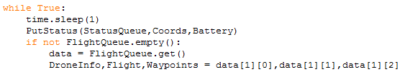
The drone hardware operates in a continuous loop. Each cycle the program sleeps for 1 second, updates the drones status in the StatusQueue and checks for flight data in the FlightQueue, if the queue is empty the cycle restarts.
Should a flight be available the data is obtained from the queue and the information is extracted. Currently data[0] is not in use and irrelevant.

The AllWaypoints list is created containing all waypoints as well as the start and end coordinate waypoint object. This forms a list of all the points the drone must pass through to complete the flight correctly.

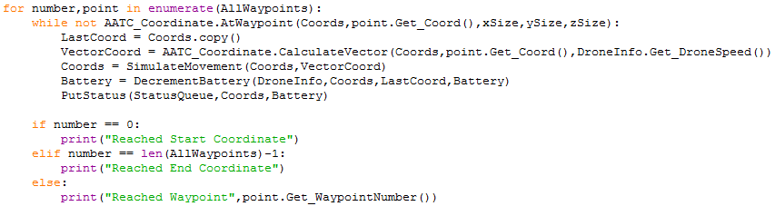
The enumerated for loop obtains the range numbers as well as the objects in the AllWaypoints list ( acts as an “in range + for item in “ combination). A while loop then continiously duplicates the coordinate, calculates the movement vector coordinate object using the current and target coordinates as well as the drones speed , moves the coordinate object by this vector ( sleeps in process to simulate movement time) , calculates the battery level based on the difference between the last coordinate ( duplicated coordinate) and the new coordinate. Finally the status is updated via the PutStatus procedure. The while loop continues until the drone’s coordinates are within the previously mentioned limits of the target coordinate, this simulates moving towards a coordinate until one reaches it.
Once this loop completes the program will check which waypoint was obtained at that time. If number = 0 then it must have been the start coordinate, if number = len(AllWaypoints) -1 it must have been the end coordinate, if none of these then it must have been a generic waypoint and the relevant waypoint number is displayed.

Once the flight is completed the status is updated with the flight marked as complete using the flightID and EmptyOverride enabled as to force the transmission of the message. The FlightQueue is then marked as done.

Startup
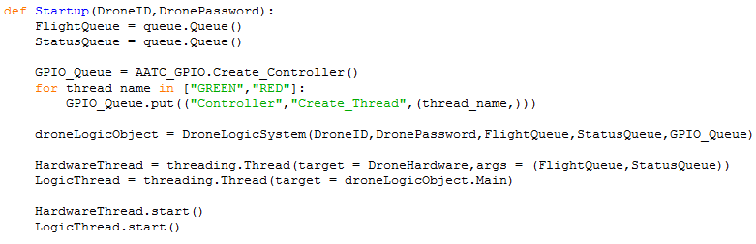
The Startup method is used to start the drone simulation. It requires as arguments the DroneID as well as the DronePassword of the drone to be simulated. The Status and Flight Queues are created to allow communication between the hardware and logic components of the drone.
A Thread Controller object is created to control the GPIO pins. This Controller is created here so if desired the hardware thread may have access the the GPIO controller. The threads for the RED and GREEN LEDs are created so control may taken from any location rather than have overlapping command producing strange results ( i.e. blinking and pattern on seperate threads). The DroneLogic system is created and the threads for the hardware and logic components are created and started, starting the drone simulation.

